Pembinaan Olimpiade Propinsi Jawa Timur Tahap I
Bagian A

A. MULTIPLE CHOICE QUESTIONS
Choose the correct answer and write its letter in the brackets provided.
To answer Questions 1-3, select the appropriate letter A-D below.
A = chloroplast
B = nucleus
C = cytoplasm
D = cell wall

1. The part in which cellulose is found (……)
2. The part concerned with the intake of water by osmosis (……)
3. The part in which starch is made (……)
4. An Amoeba had its nucleus removed by means of a fine glass tube but it was not otherwise damaged. For several days it continued to move and fed, but it did not reproduce. An intact Amoeba, used as control, reproduced twice in that time. What do you conclude from this experiment about the role of the nucleus in Amoeba?
A The nucleus controls the normal activity of the cell.
B The nucleus is essentials for life.
C The nucleus is essentials for cell division.
D The nucleus is the only part of the cell to contain DNA. (……)

Question 5 and 6 refer to the cellular structures listed below.
(1) cell membrane (plasmalemma) (3) cytoplasm
(2) cellulose cell wall (4) sap vacuole membrane (tonoplast)

5. Which two structure occur only in plant cells?
A 1 and 2 B 1 and 3 C 2 and 3 D 2 and 4 (……)
6. In a plant cell, such an onion epidermal cell, which two structures woul be selectively permeable, allowing molecules of water and small solute molecule to pass through from outside the cell, but preventing the passage of large solute molecule?
A 1 and 2 B 1 and 3 C 2 and 3 D 2 and 4 (……)

7. Which one of the following , A, B, C, or D, lists the structures which are present in animal cells?
Cell membrane Cell wall Choloroplasts Chromosomes Cytoplasm
A Absent Present Present Present Present
B Present Absent Absent Present Present
C Present Absent Present Present Absent
D Present Present Absent Absent Present
(……)
8. Which labelled structure, A, B, C or D, on the diagram below, contains a large amount of DNA?
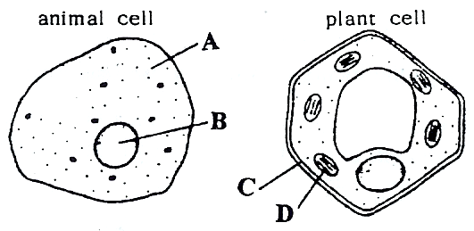
(….…)

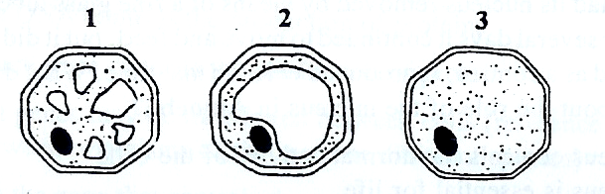
9. The diagrams show transverse sections of the same plant cell during three different stages of its growth.
In which order do these stages occur?

First Last
A 1 2 3
B 2 3 1
C 2 1 3
D 3 1 2
(….…)

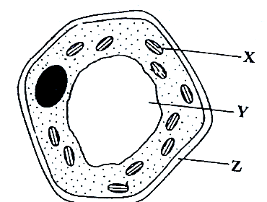
10. The diagram shows a spongy mesophyll cel from the leaf of a green plant.
What are the labelled structures?
X Y Z
A Chloroplast Cytoplasm Cell membrane
B Chloroplast Vacuole Cell wall
C Nucleus Cytoplasm Cell wall
D Nucleus Vacuole Cell membrane
(………)
11. Which of the following structure is found in both animal and plant cells?
A Cell membrane C Chloroplast
B Cellulose cell wall D Sap vacuole (………)

12 Which of the following combinations includes three structures of all of which are found in plant cells but not in animal cells?
A cellulose cell wall chloroplast cell membrane
B cellulose cell wall chloroplast sap vacuole
C cellulose cell wall nucleus sap vacuole
D chloroplast cell membrane nucleus (………)

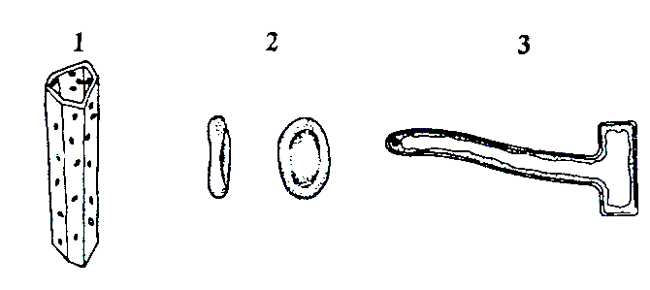
13. The diagrams show three different types of cells, not drawn to scale.

What are these cells?
1 2 3
A Red blood cell Root hair cell Xylem vessel
B Red blood cell Xylem vessel Root hair cell
C Root hair cell Red blood cell Xylem cell
D Xylem vessel Red blood cell Root hair cell (………)

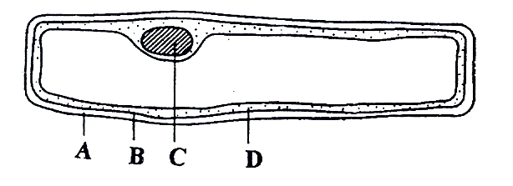
14. The diagram shows a cell from the epidermis of an onion.

Which labeled structure controls the transfer of substances into and out of the cell? (………)

15. Which of the following is needed for the transport of oxygen by red blood cells?
A Contractile fibres C Nucleus
B Haemoglobin D Thick outer wall (………)

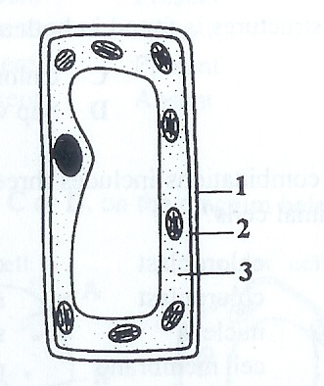
16. The diagram shows the structure of a cell from the leaf of a green plant.

What are the numbered parts of the cell?
1 2 3
A Cell membrane Cell wall Cytoplasm
B Cell membrane Cytoplasm Cell wall
C Cell wall Cytoplasm Cell membrane
D Cell wall Cell membrane Cytoplasm

17. Below is a list of cell structures.
1. Cell wall 4. Cytoplasm
2. Cell membrane 5. Nucleus
3. Chloroplast 6. Sap vacuole
Which of these structures are found in both animal cells and in plant cells?
A 1, 2 and 5 B 1, 3 and 5 C 2, 3 and 5 D 2, 4 and 5 (………)

18. Which structure is present in a plant cell but not in an animal cell?
A Cell membrane B Cell wall C Cytoplasm D Nucleus (………)

19. Which part of an actively growing root takes up the most water from the soil?
A Cortex B Lateral roots C Root hairs D Root cap (………)
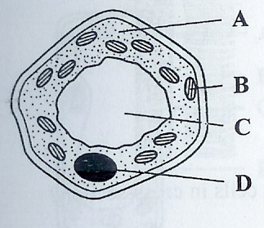
20. Which structure in the plant cell contains chromosomes?

(………)

21. The table shows three functions of cells.
Which row is correct?
Absorption Support Transport
A Red blood cell Muscle cell Root hair cell
B Root hair cell Xylem vessel Red blood cell
C Muscle cell Red blood cell Xylem vessel
D Xylem vessel Root hair cell Muscle cell (………)
22. Which structures are present in animal cells?
 | cell membrane | cell wall | chloroplasts | cytoplasm | key:
A | x | √ | √ | √ | √ = structure present
B | √ | x | x | √ | x = structure absent
C | √ | x | √ | x
D | √ | √ | x | √ | (………)

23. A 50% solution of human saliva was mixed in test-tube with an equal quantity of 0.1% starch solution. It was left for 30 minutes and then several drops of iodine solution were added. After shaking, the contents of the test-tube appeared
A white B brown C green D blue-black (………)
24. From which region of the digestive system had the enzyme used in the experiment been extracted?
A Pancreas B Liver C Salivary gland D Stomach wall (………)
25. Which enzyme, substrate and conditions are needed for the digestion of food in the stomach?
Enzyme Substrate Conditions
A Amylase Starch Acid
B Amylase Starch Alkaline
C Protease Protein Acid
D Protease Protein Alkaline (………)
26. Which one of the following combinations of nutrient is necessary for healthy bone formation? A Calcium and vitamin C C Iron and phosphate
B Calcium and vitamin D D Iron and vitamin D (………)
27. Vitamin stimulates uptake of calcium from the intestine and promotes healthy development of bones and teeth?
A Vitamin A (retinol) C Vitamin C (ascorbic acid)
B Vitamin B (thiamine) D Vitamin D (calciferol) (………)
28. Five foods which could form part of a healthy diet are listed below.
1 Citrus fruits 2 Fresh vegetables 3 Meat 4 Milk powder 5 Bread
Which of these foods contain the highest concentrations of vitamin C?
A 1 and 2 B 1 and 3 C 2 and 4 D 3 and 5 (………)
29. What tests are used to detect the presence of starch, reducing sugar, protein and fat in sample of food?
Strach Reducing sugar Protein Fat (………)
A Biuret Ethanol Benedict’s solution Iodine solution
B Benedict’s solution Iodine solution Ethanol Biuret
C Ethanol Biuret Iodine solution Benedict’s solution
D Iodine solution Benedict’s solution Biuret Ethanol
30. Which of the following foods contains the highest concentrations of protein and iron?
A Citrus fruits B Fresh vegetables C Meat D Milk powder (………)
31. Which food contains the highest concentrations of calcium and vitamin D?
A Bread B Fresh vegetables C Meat D Milk powder (………)
32. Which component of the diet prevents constipation?
A Fibre B Minerals C Protein D Vitamins (………)
33. Tennis players often eat bananas during long matches. Which nutrient in a banana is important during the match?
A Carbohydrate B Fibre C Iron D Vitamin C (………)
34. In which of the following parts of the mammalian digestive system in hydrochloric acid produced?
A Gall bladder B Glands in the stomach wall C Pancreas D Liver (………)
35. Which one of the following enzymes is directly responsible for the production of fatty acids and glycerol?
A Amylase B Peptidase C Trypsin D Lipase (………)
36. In which one of the following stucture is most water absorbed from the contents of the mammalian gut?
A Caecum B Colon C Ileum D Rectum (………)
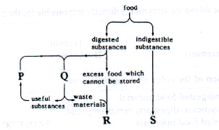
37. The diagram below shows the fate of ingested food materials.

Which one of the following correctly identifies the processes P, Q, R and S? (………)
P Q R S
A Metabolism Secretion Defaecation Excretion
B Secretion Metabolism Excretion Defaecation
C Excretion Defaecation Secretion Metabolism
D Defaecation Excretion Metabolism Secretion
38. Which one of the following is an enzyme by the pancreas?
A Insulin B Lipase C Maltase D Pepsin (………)
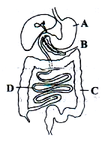
39. The diagram shows the human alimaentary canal.
Which region A, B, C or D, produces the enzyme
responsible for the first stage of protein digestion?

40. Where does bile enter the alimentary canal?
A Oesophagus B Stomach C Duodenum D Colon (………)

41. Pernapasan tumbuhan dilakukan pada waktu: (………)
A siang hari saja B malam hari saja C pagi dan sore hari D sepanjang hari dan malam
42. Pernapasan pada kita dapat dilakukan dengan cara ... A pernapasan dalam dan pernapasan luar C pernapasan dada dan pernapasan perut
B pernapasan kuat dan pernapasan lemah D pernapasan basah dan pernapasan kering
43. Oksigen dalam tubuh kita digunakan untuk … A kesehatan tubuh B mengoksidasi darah C menambah tenaga D menetralisir lemak
44. Pernapasan yang terjadi bila tulang rusuk mengembang dan mengecil disebut pernapasan … A dada B besar C perut D lambung
45. Sendi yang dapat digerakkan kedua arah disebut sendi …
A peluru B pelana C engsel D putar
46. Kelainan tulang belakang karena bengkok ke kanan atau ke kiri disebut ... A skoliosis B fraktura C lordosis D kifosis
47. Angsa untuk mengerami telurnya memerlukan waktu …
A 21 hari B 42 hari C 28 hari D 36 hari
48. Setelah ekor cecak mengalami putus akan tumbuh kembali melalui proses ..
A reproduksi B regenerasi C assimilasi D inseminasi
49. Perubahan warna kulit bunglon disebut ...
A adaptasi B mimikri C autotomi D kamuflase
50. Kelompok makhluk berbeda dan tinggal bersama dalam suatu lingkungan tertentu disebut … A ekosistem B populasi C komunitas D habitat

B. ANSWER THE FOLLOWING QUESTIONS IN THE SPACES PROVIDED

51. Name the secretion poured into the alimentary canal that contains no enzyme but helps in the digestion of fats. …………………
52. Name the region of the alimentary canal where digested food is absorbed. …………….
53. Transpiration increases when conditions become …………..
54. When pigeon bird in flight, transfer of oxygen gas with carbon dioxide happened in …….
55. The tissue of body human being network which useful in maintaining body temperature remain to 37ºC is ……………
56. Blood component which have do not in form of cell again is………

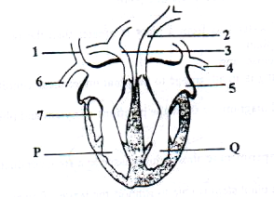
Examine the diagram below

57. Which of the following blood vessels carry oxygenated blood? ………………
58. Which of the following is not involved in carrying blood from P to Q? ………………

59. Carbon dioxide is carried in human blood mainly by ……………
60. When the right atrium (auricle) contracts, blood flows from the right atrium into the ……..
61. Oxygen passes through the stomata of the leaves by ………..
62. What are the end product(s) of respiration in green plants? ………
63. The leaves of a green plant respire in …… ………….
64. The most important function of sweat is to remove from the body excess. ……………
65. The amount of light entering the eye is controlled by the ………
66. The light—sensitive cells of the eye form a layer called ……..
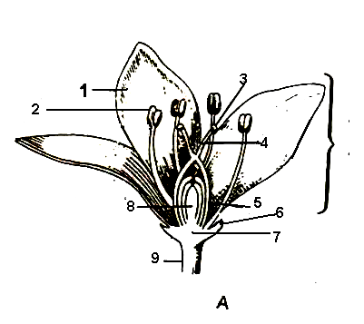
The diagram shows a section of flower, which represent the main parts of a flower.
67. From parts of flower, which as a perianth are …….

68. When the ovary of a flowering plant matures after fertilization, it forms the ……….
69. Pollination occurs when pollen grains are transferred to the …………..
70. After fertilization, which structure develops into the seed of a flowering plant? …………..
71. In which part of the flower does fertilization occur? ………………
72. Kita sering mengacungkan jempol (ibu jari) ke atas untuk setiap menyatakan sesuatu yang bagus. Tulang lengan bawah yang lurus dengan ibu jari tersebut adalah ……….
73. Jambu biji, jagung, pepaya, kurma, kacang kedele, alpukat, salak, dan padi. Di antara tumbuhan tersebut, sebutkan sedikitnya tiga tumbuhan yang tidak termasuk dalam kelompok tumbuhan monokotil …………….
74. Makhluk hidup yang menghancurkan dedaunan menjadi tanah yang subur ialah ...................
75. Bagian darah yang cair dan sudah dipisahkan dari fibrinogennya disebut ……..

C. ANSWERS THE FOLLOWING QUESTIONS

76. Define the term digestion.
77. Explanion the term transpiration in flowering plants.
78. State three important functions of skin.
79. Explain what is function of the iris structure in human eye!
80. Distinguish between pollination and fertilization!
81. Explain what is meant by “many flowering plants are hermaphrodite”
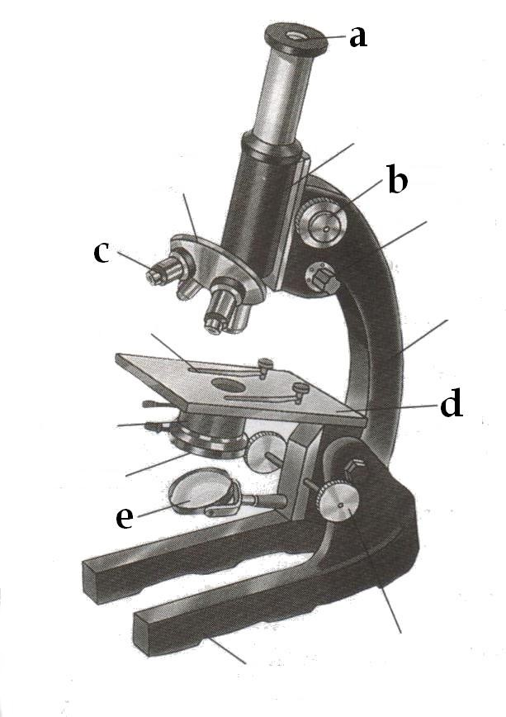
82. Perhatikan gambar alat berikut ini!

Sebutkan nama bagian dan fungsi yang diberi label!
a. ..........................; fungsi ................................................
b. ..........................; fungsi ................................................
e. ..........................; fungsi ................................................

Bagian B

1. Karbondioksida masuk ke dalam daun melalui….
- lentisel
- stomata
- kutikula
- urat daun
- trikoma

2. Stomata berfungsi untuk….
A) pengangkutan zat hara di dalam tumbuhan
B) mengatur pengeluaran uap air dari dalam tumbuhan
C) pengangkutan air dan mineral di dalam tumbuhan
D) mengeluarkan air dalam proses gutasi
E) mengeluarkan air dan mineral dario dalam tumbuhan

3. Pada saat serbuk sari menempel pada kepala putik, maka pada saat itu terjadi proses….
- pembuahan
- perkecambahan
- penyerbukan
- perkembangbiakan
- pertumbuhan

Kasus berikut untuk soal no 4 dan 5
Suatu tumbuhan air, Hydrilla disimpan di dalam akuarium kecil. Di samping akuarium tersebut ditempatkan sebuah lampu yang akan menyinari akuarium. Pada saat lampu menyala, ternyata dari tumbuhan air tersebut keluar gelembung udara. Ketika lampu mati, gelembung udara tersebut tidak dihasilkan lagi.
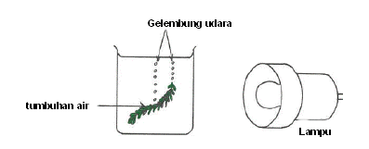
4. Gas apakah yang terdapat di dalam gelembung udara tersebut?
- Karbondioksida
- Oksigen
- Nitrogen
- Hidrogen
- Karbonmonoksida
5. Proses apakah yang berlangsung di dalam tumbuhan tersebut sehingga muncul gelembung udara?
- Transpirasi
- Respirasi
- Penguapan
- Fotosintesis
- Reproduksi

6. Apabila tumbuhan tersebut disimpan di tempat gelap tanpa disinari lampu, ternyata tidak terbentuk gelembung udara. Mengapa gelembung tidak terbentuk?
- Tumbuhan tidak melakukan fotosintesis, karena untuk proses fotosintesis diperlukan cahaya
- Tumbuhan tidak melakukan respirasi dan fotosintesis, karena tidak ada oksigen yang terbentuk
- Tumbuhan tidak melakukan transpirasi sehingga tidak ada uap air yang keluar
- Tumbuhan tidak melakukan respirasi, sehingga tidak ada karbondioksida yang dihasilkan
- Tumbuhan tidak melakukan reproduksi sehingga tidak ada karbondioksida yang dikeluarkan

7. Pilihlah mana dari pernyataan berikut ini yang benar!
- Jika Bulan dalam fasa oposisi (relatif terhadap Matahari) maka ia sedang berada dalam fasa kwartir pertama
- Orbit bulan berinklinasi 23,5 derajat terhadap ekliptika
- Permukaan Bulan bagian belakang tidak pernah terlihat oleh manusia
- Permukaan Bulan bagian belakang tidak pernah tersinari Matahari
- Pada saat gerhana Bulan Total, Bulan tidak sama sekali gelap tetapi tampak tersinari tipis karena cahaya Matahari terbelokkan oleh atmosfir Bumi

8. Gerhana Bulan Total dapat diamati….
  - hanya dalam waktu singkat sepanjang lajur tertentu dari permukaan Bumi

dari kira-kira setengah permukaan Bumi
  - hanya pada saat Bulan baru
  - hanya saat bulan berada di meridian pada tengah malam
  - pada saat Matahari berada tepat di atas ekuator

9. Pada saat Bulan Purnama, jumlah bintang yang tampak akan lebih sedikit dibanding saat-saat fasa lain dari Bulan. Hal ini terjadi karena….

penghamburan sinar Bulan oleh atmosfir Bumi
- pemantulan sinar Bulan oleh permukaan Bumi
- pembiasan cahaya bintang oleh atmosfir Bumi
- cahaya bintang menjadi redup
- cahaya bintang menjadi terang

10. Which cycle is correct?
A. morning sunrise afternoon sunset
B. summer fall winter spring
C. seed mature plant fruit seedling
D. baby teenager child adult

11. Which statement explains why the Sun appears to rise and set each day?
A. Earth rotates.
B. The Sun rotates.
C. The Sun revolves around Earth.
D. Earth revolves around the Sun.

12.Which statement describes the general path the Sun takes as it appears to move across the sky for an observer in Malang State?
A. The Sun rises in the west and sets in the east.
B. The Sun rises in the east and sets in the west.
C. The Sun rises in the north and sets in the south.
D. The Sun rises in the south and sets in the north.

13. Which unit is used to measure how warm or cool the air is?
A. grams
B. kilometers
C. degrees Celsius
D. cubic centimeters

14. A soil sample contains living and nonliving materials. Which material was once living?
A. sand particles
B. decomposing leaves
C. small pebbles
D. water droplets

15. Water is boiled in a pan on a stove. The state of matter of the water changes from
A. liquid to solid
B. solid to liquid
C. gas to liquid
D. liquid to gas

16. Which kind of energy is produced when a student beats a drum?
A. electrical
B. sound
C. light
D. chemical

17. Electricity traveling through a wire is an example of
A. a force applied by a simple machine
B. energy flowing through the water cycle
C. Earth’s gravitational pull on an object
D. energy being transferred from place to place

18. Which forms of energy are produced by a burning candle?
A. heat and mechanical
B. electrical and sound
C. light and electrical
D. heat and light

19. In order to survive, all animals need
A. roots, leaves, and stems
B. eyes, nose, and ears
C. light, soil, and nutrients
D. food, water, and air

20. What does a seed contain that provides energy for germination?
A. water
B. stored food
C. soil
D. sunlight

21. The main purpose of a plant’s flowers is to
A. provide support
B. provide water
C. produce seeds
D. produce food

22. Which color fur will best protect a rabbit from a hawk in a snowy field?
A. brown
B. gray
C. white
D. black

23. Which food is an example of a healthy snack?
A. an apple
B. a candy bar
C. cookies
D. potato chips

24. What is one healthy way that people can help to maintain their weight?
A. washing their hands regularly
B. brushing their teeth twice daily
C. sleeping 8 hours daily
D. exercising regularly

25. What is the role of a producer in a food chain?
A. preys on animals
B. eats decayed animals
C. makes food
D. eats plants

Bagian C

A. MULTIPLE CHOICE QUESTIONS
Choose the correct answer and write its letter in the brackets provided.
01. Which statement about enzymes is correct?
A They are all proteins.
B They are changed by the chemical reactions they control.
C They are destroyed by temperatures below 10°C.
D They are found only in the alimentary canal. (……)

02. Where is lipase produced, and into which part of the intestine is it secreted?
 | produced in | secreted into
A | liver | duodenum
B | liver | ileum
C | pancreas | duodenum
D | pancreas | ileum
(……)
03. Which dietary imbalance does not lead to the health problem stated?
 | dietary imbalance | health problem
A | lack of fresh fruit | constipation and scurvy
B | lack of milk and cod liver oil | rickets and diarrhoea
C | too many sweets an cakes | anaemia and rickets
D | too much full-fat cheese and fried food | chronic heart disease

04. What are the function of a colon?
 | water absorbed | enzymes secreted
A | no | no
B | no | yes
C | yes | no
D | yes | yes
(……)
05. Which conditions will increase the temperature rate of a plant?
 | temperature | humidity
A | high | high
B | high | low
C | low | high
D | low | low
(……)
06. What happens during anaerobic respiration in muscles?
 | carbon dioxide produced | oxygen used | water produced
A | no | no | no
B | no | yes | yes
C | yes | yes | no
D | yes | no | yes
(……)
07. What happens to blood as it passed through a kidney machine?
A Carbon dioxide is removed C Oxygen is added
B Glucose is added D Urea is removed (………)

08. In food chain, which trophic level has the most energy passing through it?
A Carnivores C Herbivores
B Decomposers D Producers (………)

09. Which process does not result in the return of carbon dioxide to the atmosphere?
A Combustion of fossil fuels C Decomposition of humus
B Photosynthesis by green plants D Respiration by bacteria (………)

10. Which method of control would not be effective against the spread of the materiall parasite?
A Drainage of swamps and marshes
B Isolation of infected people
C Sewage treatment and disposal under cover
D Spraying walls of houses with insecticide (………)

Bagian D

Type 1

Do the following Problems correctly.

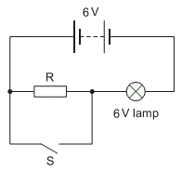
- When the circuit shown is connected with switch S open, the 6V lamp glows.
What happens to the brightness of the lamp when switch S is closed?
A It becomes brighter.
B It remains the same.
C It becomes dimmer.
D It goes off.

3. Why are the electric lamps in a house lighting circuit normally connected in parallel?
A The current in every circuit must be the same.
B The lamps are always switched on and off at the same time.
C The voltage across each lamp must be the mains voltage.
D When one of the lamps blows, all the others go out.

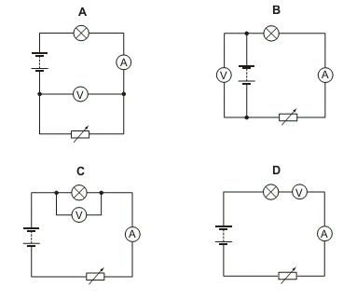
4. Which circuit should be used to find the resistance of a lamp?

5. Two rods X and Y look the same.
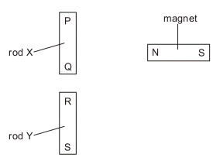
The N pole of a magnet is brought close, in turn, to each end of both rods. The results of these four actions are shown in the table.
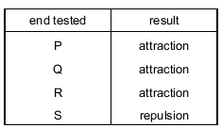
Which of the rods is a magnet?
A neither of the rods
B both of the rods
C rod X only
D rod Y only

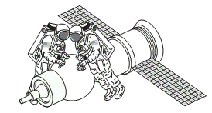
6. Two astronauts without radios can only communicate in space if their helmets are touching. There is no air in space.

What does this show about sound?
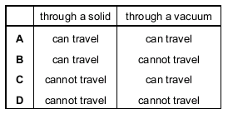

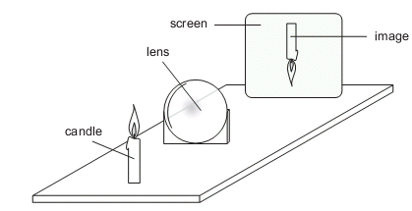
7. A thin converging lens is used to produce on a screen a focused image of a candle.
The screen and the lens are moved back and forth and various focused images are produced on the screen.
Which statement is always true?
A The image is at the principal focus (focal point) of the lens.
B The image is bigger than the object.
C The image is closer to the lens than the object is.
D The image is inverted.

8. Rays of light enter and leave a box.

What could be inside the box to make the rays behave as shown?
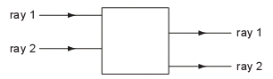
A a converging lens
B a parallel-sided glass block
C a plane mirror
D a triangular prism

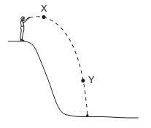
9. A man standing at the top of a cliff throws a stone. Which forms of energy does the stone have at X and at Y?
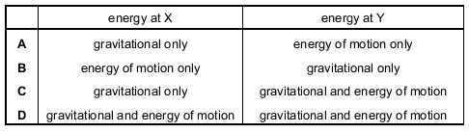

10. Which property do all metals have?
A They are hard.
B They are less dense than water.
C They are very reactive.
D They conduct electricity.
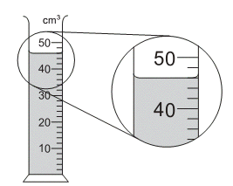
11. A measuring cylinder is used to measure the volume of a liquid.
What is the volume of the liquid?
A 43 cm³ B 46 cm³ C 48 cm³ D 54 cm³

12.A man crosses a road 8.0 m wide at a speed of 2.0m/s. How long does the man take to cross the road?
A 4.0 s B 6.0 s C 10 s D 16 s

14. Change in state from a substance releasing a heat energy in the diagram below is
- 1 and 2
3
2
1
4

Solid

Liquid

Gas
- 2 and 3
- 3 and 4
- 1 nd 4

16. According to Figure below, if the pendulum oscillates passing through the points A, O, and B needs 0.30 second of time, the period of its oscillation is ……. Seconds
A. 0.15 C. 0.45
A
B
O
B. 0.3 D. 0.6

17. A boy of weight 600 N sits on the see-saw illustrated in the figure below at a distance of 1.5 m from pivot. What is the force F required at the other end to balance the see-saw?
600 N
F
2.0 m
Pivot
1.5 m
A. 450 N C. 500 N
B. 600 N D. 300 N

18. The heating element of an electric kettle with a resistance of 38.4 Ω is connected across a 240 V power supply. Calculate the current flowing through the element:
A. 5.25 A C. 921.6 A
B. 6.25 A D. 9216 A

19. The movement of the eyes to change the shape of eyes lens is called
A. reflection C. accommodation
B. contraction D. refraction

20. Permanent magnets are made of hard magnetic materials such as
A. Iron C. Steel
B. Copper D. Carbon

21. A dolphin, which is at 4.500 m from undersea laboratory, produces a sound. If the sound propagates in the water with speed of 1.500 m/s, how long will it take so somebody in laboratory can detect the dolphin’s sound?
A. 6750000 seconds C. 3 seconds
B. 0.33 seconds D. 6000 second

22. Look at the figure below if the five light bulb have the same characteristics, which light bulb is brighter than others

bulb 1
4
2
3
1
bulb 2
bulb 3
bulb 4

23. Water boiling at 100ºC is heated continuously. In fact, its temperature does not change. This indicates that…
heat energy resists the change of temperature

heat energy changes the state of substance
heat energy is proportional to the change of temperature.
Heat energy which is provided is equal to heat energy which is released.

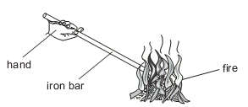
24. An iron bar is held with one end in a fire. The other end soon becomes too hot to hold. How has the heat travelled along the iron bar?
A by conduction
B by convection
C by expansion
D by radiation

25. 20 The drawing shows a wave. Which labelled distance is the wavelength?
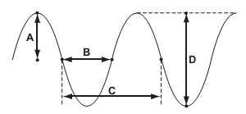

26. Which diagram correctly shows a ray of light passing through a rectangular glass block?
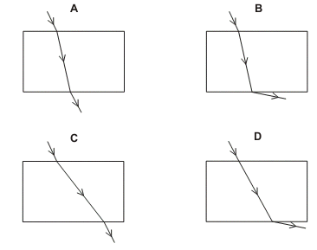
27. The ray diagram shows how an image is formed by a converging lens.
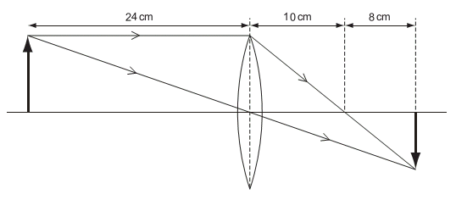
What is the focal length of this lens?
A 8cm B 10 cm C 18 cm D 24 cm

Type 2

1. Figure below shows the lens of a simple camera being used to photograph an object.

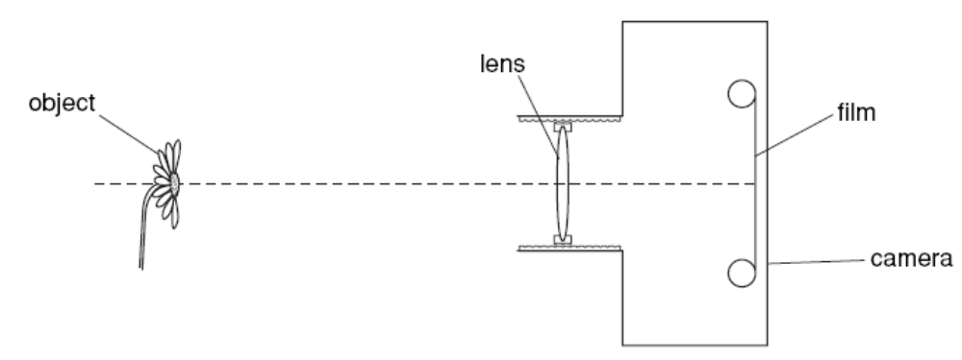
The lens forms a focused image of the object on the film.
(a) Draw two rays from the top of the object to show how the lens forms the image.
(b) The object moves closer to the camera. State how the lens is adjusted to keep the
image in focus.
.........................................................................................................................................
.........................................................................................................................................
...................................................................................................................................
(c) Complete Fig. 2.2 to show how white light is split into a spectrum when it passes
through a glass prism.

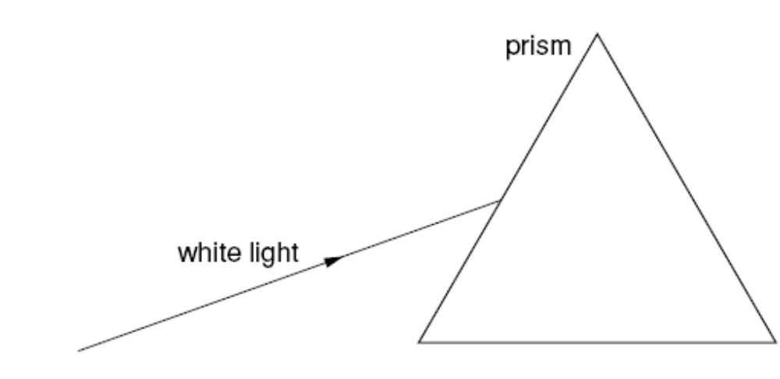

2. The balloon contains no gas initially. When it is connected to the cylinder, gas enters the balloon. The pressure in the cylinder decreases.
(a) Explain why the molecules inside the cylinder
(i) exert a large pressure initially,
.................................................................................................................................
.................................................................................................................................
.............................................................................................................................
(ii) exert a smaller pressure in the cylinder when the balloon is filled.
.................................................................................................................................
.................................................................................................................................
............................................................................................................................ [1]
(b) The volume of the cylinder is 0.0020m3. The pressure inside the cylinder is initially
200 atmospheres. When the cylinder is connected to the balloon, the final pressure in the cylinder and the balloon is 1.0 atmosphere.
The temperature of the gas remains constant.
Calculate the final volume of gas in the balloon. State the equation that you use.

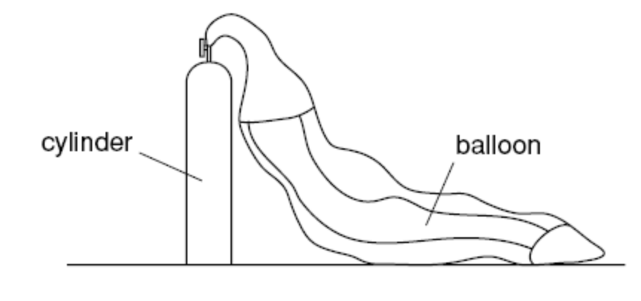
3 . Fig. 4.1 shows a hydroelectric power station. Water from the lake is used to produce electricity in the turbine house.
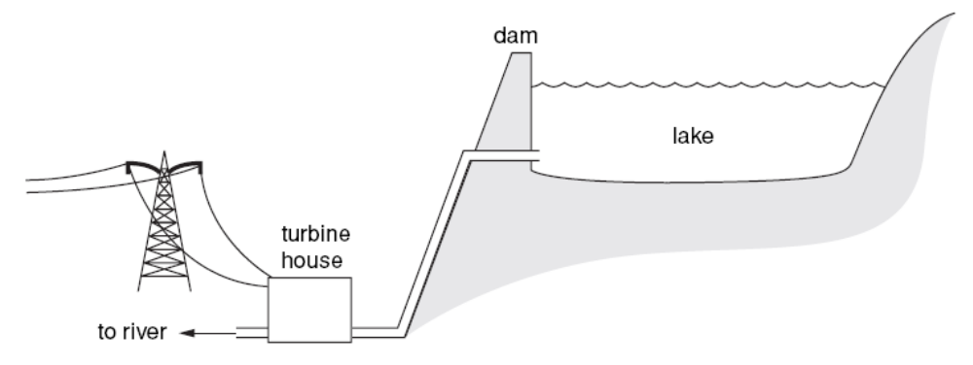
(a) State where the water in Fig. 4.1 has the least potential energy.
...................................................................................................................................
(b) In 30 minutes, the water loses 5.0 ⋅ 109 J of energy and 4.5 ⋅ 109 J of electrical energy is produced in the turbine house.
(i) Calculate the efficiency of the energy conversion.
(ii) Calculate, in watts, the electrical power output from the turbine house.
(c) Some power stations burn coal to produce the same electrical power output. State one advantage of the hydroelectric power station.
.........................................................................................................................................
.........................................................................................................................................
...................................................................................................................................
(d) State one harmful effect that the hydroelectric power station may have on the
environment.
.........................................................................................................................................
...................................................................................................................................

4. Fig. 5.1 shows a coil of wire wrapped around a plastic tube. Inside the tube are two pieces of soft iron. When the switch is closed, the compass needles point in the direction of the magnetic field produced at each position. You may ignore the magnetic field of the Earth in this question.
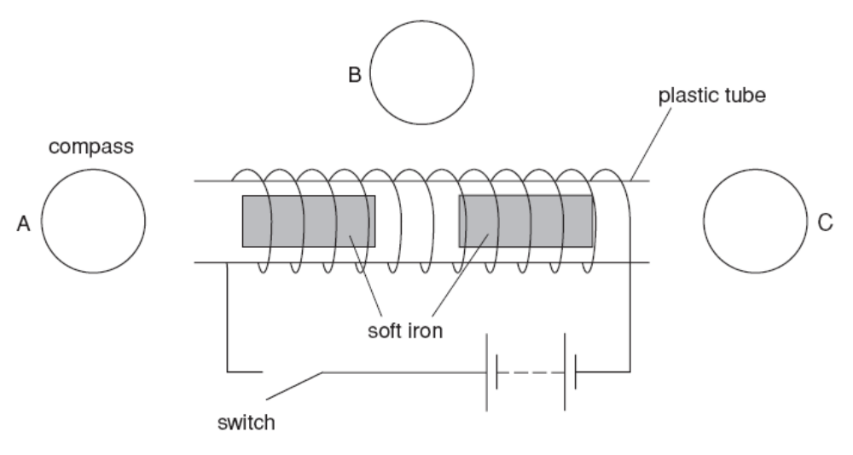
(a) On Fig. 5.1 mark arrows, in compasses A, B and C, to show the direction of the
magnetic field at each position after the switch has been closed.
(b) When the switch is closed, the two pieces of soft iron in the tube become magnets and move.
(i) On Fig. 5.1, mark the poles formed on each piece of soft iron.
(ii) State and explain how the pieces of iron move.
.................................................................................................................................
.................................................................................................................................
............................................................................................................................
(c) State the effect on the magnetic field of
(i) reversing the direction of the current,
.................................................................................................................................
.............................................................................................................................
(ii) reducing the size of the current.
.................................................................................................................................
.............................................................................................................................

6. In this experiment you will make some measurements on an electrical circuit that contains a filament lamp.
You have been provided with a variable power supply, a switch, an ammeter, a voltmeter, a filament lamp and some connecting leads.
(a) The Supervisor has set up a circuit. Close the switch and record the potential difference V across the filament lamp and the current I in the circuit. Record your readings in the table on page 5 of your Answer Booklet. Insert appropriate units in the table. Open the switch in the circuit as soon as you have recorded your readings.
(b) Calculate the resistance R of the filament lamp using R = V / I.
(c) Repeat parts (a) and (b) for two higher power supply voltages of up to but not more than 6 V.
Record your readings of V and your values of R in the table. [2]
(d) Comment on the results you have obtained with particular reference to the resistance of the filament lamp.

5. In this experiment you will investigate how the time for one oscillation of a simple pendulum depends on the height of the pendulum bob above the bench.
You have been provided with a simple pendulum that has been set up by the Supervisor, a metre rule, a marker so that you can judge when the pendulum bob passes through the centre of the oscillation, a set square and a stopwatch. You must not adjust the height of the boss that is holding the clamp at the top of the pendulum at any stage during the experiment.
(a) Record, on page 6 of your Answer Booklet, the vertical height h of the centre of the
pendulum bob above the bench surface. Explain with the aid of a diagram how you ensured that the height measured was vertical. [2]
(b) Displace the pendulum bob approximately 2 cm to the left of its rest position and determine the time T for one complete oscillation. One complete oscillation is illustrated in Fig. 4.1. The time T is best determined by measuring the time for 10 oscillations and then dividing this time by 10.
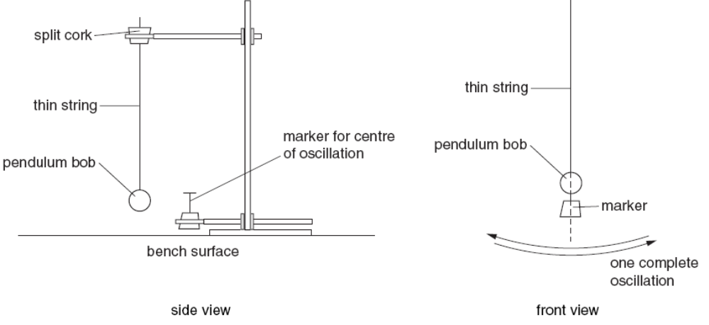
(c). Repeat parts (a) and (b) for 5 further values of the height h of the pendulum bob above the bench. Record all your values of h, 10 T and T in the table on page 6 of your Answer Booklet.
In order to change h, the top of the pendulum (split cork) should be kept in the same position and the length of the pendulum should be adjusted. This can be done by loosening the jaws of the clamp, pulling the string through the cork and then retightening the jaws of the clamp.
(d) Calculate and record in your table values for T 2.
(e) Using the grid on page 7 of your Answer Booklet, plot a graph of T 2/ s2 on the y-axis against h / cm on the x-axis.
(f) Determine the gradient G of your graph.

